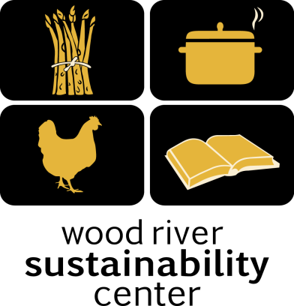

Local Food – Local People
Syringa Mountain School
Lunch Program May & June 2018

Tuesday, May 1st
Taco Salad
with Grass Fed Beef, Roasted Tomato Salsa and Queso Fresco, Rice and Beans
Includes onions, jalapeños, garlic, tomato and cilantro & Corn Tortilla Chips. Gluten free!

Wednesday, May 2nd
Beef Enchiladas
with Grass Fed Beef, Onions, peppers, cheese and tomatoes. With a Green Salad

Thursday, May 3rd
Veggie Pizza
Marinara , Mushrooms, Peppers, Onions, Tomatoes, Cheese. Green Salad

Friday, May 4th ~ Sack Lunch

Monday, May 7th
Grilled Cheese with Butternut Squash Soup
Butternut Squash, Leeks, Celery, Onions, Raw Cow’s Milk with a Green Salad

Tuesday, May 8th
Taco Salad
with Grass Fed Beef, Roasted Tomato Salsa and Queso Fresco, Rice and Beans
Includes onions, jalapeños, garlic, tomato and cilantro & Corn Tortilla Chips. Gluten free!

Wednesday, May 9th
Macaroni & Cheese
with Elbow Macaroni, Cheese, Raw Cow’s Milk, Steamed Broccoli With a Green Salad

Thursday, May 10th
Vegetable Soup
with Sourdough Bread and Green Salad, Includes potatoes, garlic, Carrots, Zucchini and onion.
Gluten Free except sourdough. Vegetarian

Friday, May 11th ~ Sack Lunches

Monday, May 14th
Chicken Noodle Soup
Chicken, celery, carrots and Green Salad

Tuesday, May 15th
Taco Salad
with Grass Fed Beef, Roasted Tomato Salsa and Queso Fresco, Rice and Beans
Includes onions, jalapeños, garlic, tomato and cilantro & Corn Tortilla Chips. Gluten free!

Wednesday, May 16th
Meatzzzaa Pizza
Marinara , Grass Fed Beef, Onions, Tomatoes, Cheese. Green Salad
Thursday, May 17th
Beef Enchiladas
with Grass Fed Beef, Onions, peppers, cheese and tomatoes. With a Green Salad

Friday, May 18th ~ Sack Lunch

Monday, May 21st
Grilled Cheese with Chili Soup
Grass Fed Butternut Squash, Leeks, Celery, Onions, Raw Cow’s Milk with a Green Salad

Tuesday, May 22nd
Taco Salad
with Grass Fed Beef, Roasted Tomato Salsa and Queso Fresco, Rice and Beans
Includes onions, jalapeños, garlic, tomato and cilantro & Corn Tortilla Chips. Gluten free!

Wednesday, May 23rd
Macaroni & Cheese
with Elbow Macaroni, Cheese, Raw Cow’s Milk, Steamed Broccoli With a Green Salad

Thursday, May 24th
Tomato and Basil Bisque
with Sourdough Bread and Green Salad, Includes garlic, olive oil and onion. Gluten Free except sourdough. Vegetarian

Friday, May 25th ~ Sack Lunch

Monday, May 28th ~ No School – Memorial Day

Tuesday, May 29th
Taco Salad
with Grass Fed Beef, Roasted Tomato Salsa and Queso Fresco, Rice and Beans
Includes onions, jalapeños, garlic, tomato and cilantro & Corn Tortilla Chips. Gluten free!

Wednesday, May 30th
Beef Enchiladas
with Grass Fed Beef, Onions, peppers, cheese and tomatoes. With a Green Salad

Thursday, May 31st
Veggie Pizza
Marinara , Mushrooms, Peppers, Onions, Tomatoes, Cheese. Green Salad

Friday, June 1st ~ Sack Lunch

Monday, June 4th
Grilled Cheese with Butternut Squash Soup
Butternut Squash, Leeks, Celery, Onions, Raw Cow’s Milk with a Green Salad

Tuesday, June 5th
Taco Salad
with Grass Fed Beef, Roasted Tomato Salsa and Queso Fresco, Rice and Beans
Includes onions, jalapeños, garlic, tomato and cilantro & Corn Tortilla Chips. Gluten free!

Wednesday, June 6th
Macaroni & Cheese
with Elbow Macaroni, Cheese, Raw Cow’s Milk, Steamed Broccoli With a Green Salad

Thursday, June 7th
Vegetable Soup
with Sourdough Bread and Green Salad, Includes potatoes, garlic, Carrots, Zucchini and onion.
Gluten Free except sourdough. Vegetarian

Friday, June 8th ~ Sack Lunches

