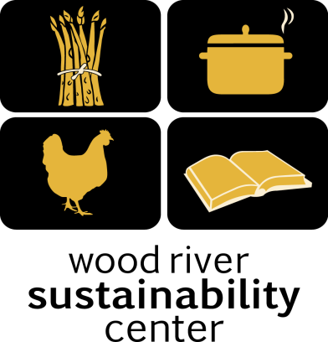

Local Food – Local People
Syringa Mountain School
Lunch Program March 2018

Thursday, March 1st
Asian Chicken Stir Fry
with Brown Rice, Onions, Celery, Carrots, Sourdough Bread and Green Salad, Includes garlic, olive oil
. Gluten Free except sourdough. Vegetarian.

Friday, March 2nd ~ Sack Lunch

Monday, March 5th
Chicken Noodle Soup
Chicken, celery, carrots and Green Salad

Tuesday, March 6th
Taco Salad
with Grass Fed Beef, Roasted Tomato Salsa and Queso Fresco, Rice and Beans
Includes onions, jalapeños, garlic, tomato and cilantro & Corn Tortilla Chips. Gluten free!

Wednesday, March 7th
Veggie Pizza
Marinara , Onions, Tomatoes, Cheese. Green Salad

Thursday, March 8th
Chicken Enchiladas
with Chicken, Onions, peppers, cheese and tomatoes. With a Green Salad

Friday, March 9th ~ Sack Lunch

Monday, March 12th
Tomato and Basil Bisque
with Sourdough Bread and Green Salad, Includes garlic, olive oil and onion. Gluten Free except sourdough. Vegetarian.

Tuesday, March 13th
Taco Salad
with Grass Fed Beef, Roasted Tomato Salsa and Queso Fresco, Rice and Beans
Includes onions, jalapeños, garlic, tomato and cilantro & Corn Tortilla Chips. Gluten free!

Wednesday, March 14th
Chicken Enchiladas
with Chicken, Onions, peppers, cheese and tomatoes. With a Green Salad

Thursday, March 15th
Twice Baked Potatoes with Chili
With Potatoes, cheese, bacon, Beef Chili served with a Green Salad

Friday, March 16th ~ Sack Lunch

Monday, March 19th thru Friday, March30th
No School – Spring Break

