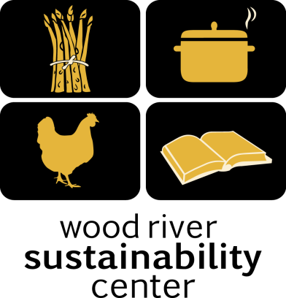

Local Food – Local People
Syringa Mountain School
Lunch Program January 2018

Tuesday, January 2nd
Taco Salad
with Grass Fed Beef, Roasted Tomato Salsa and Queso Fresco, Rice and Beans
Includes onions, jalapeños, garlic, tomato and cilantro & Corn Tortilla Chips. Gluten free!

Wednesday, January 3rd
Chicken Caesar salad
with Sourdough Croutons, Includes egg, Tabasco olive oil, Dijon & lemon juice,
Dijon and anchovies in dressing. Parmesan cheese. Gluten Free except Croutons
Thursday, January 4th
Vegetable Soup
with Beans, Corn, Peas, Onions, Garlic and Carrots with Sourdough Bread and Green Salad

Friday, January 5th
Sack Lunch

Monday, January 8th
Tomato and Basil Bisque
with Sourdough Bread and Green Salad, Includes garlic, olive oil and onion. Gluten Free except sourdough. Vegetarian.

Tuesday, January 9th
Taco Salad
with Grass Fed Beef, Roasted Tomato Salsa and Queso Fresco, Rice and Beans
Includes onions, jalapeños, garlic, tomato and cilantro & Corn Tortilla Chips. Gluten free!

Wednesday, January 10th
Chicken Noodle Soup
Chicken, celery, carrots and Green Salad

Thursday, January 11th
Veggie Alfredo
Creamy Cheese Sauce and Penne Noodles with Sourdough Bread With onions, garlic, spinach Tomatoes and Green Salad

Friday, January 12th
Chicken Caesar salad
with Sourdough Croutons, Includes egg, Tabasco olive oil, Dijon & lemon juice,
Dijon and anchovies in dressing. Parmesan cheese. Gluten Free except Croutons

Monday, January 15th
Asian Vegetable Stir Fry
with Brown Rice, Onions, Celery, Carrots, Sourdough Bread and Green Salad, Includes garlic, olive oil
. Gluten Free except sourdough. Vegetarian.

Tuesday, January 16th
Taco Salad
with Grass Fed Beef, Roasted Tomato Salsa and Queso Fresco, Rice and Beans
Includes onions, jalapeños, garlic, tomato and cilantro & Corn Tortilla Chips. Gluten free!

Wednesday, January 17th
Chicken Enchiladas
with Chicken, Onions, peppers, cheese and tomatoes. With a Green Salad

Thursday, January 18th
Twice Baked Potatoes with Chili
With Potatoes, cheese, bacon, Beef Chili served with a Green Salad

Friday, January 19th
Sack Lunch

Monday, January 22nd
Veggie Pizza
Tomato Sauce, Peppers, Onions, Garlic and Cheese with a Green Salad

Tuesday, January 23rd
Taco Salad
with Roasted Tomato Salsa and Queso Fresco, Corn & Beans Salad
Includes onions, jalapeños, garlic, tomato and cilantro & Corn tortillas. Gluten free!

Wednesday, January 24th
Chicken Pot Pie
With Chicken, Corn, Peas, Green Beans, Carrots, Celery and Potatoes.

Thursday, January 25th
Meatzza Pizza
With Tomato Sauce, Beef, Onions, Garlic and Cheese served with a Green Salad

Friday, January 26th
Sack Lunch

Monday, January 29th
Tomato and Basil Bisque
with Sourdough Bread and Green Salad, Includes garlic, olive oil and onion. Gluten Free except sourdough. Vegetarian.

Tuesday, January 30th
Taco Salad
with Grass Fed Beef, Roasted Tomato Salsa and Queso Fresco, Rice and Beans
Includes onions, jalapeños, garlic, tomato and cilantro & Corn Tortilla Chips. Gluten free!

Wednesday, January 31st
Chicken Noodle Soup
Chicken, celery, carrots and Green Salad

WRSC 308 S. River St. wrsustainabilitycenter@gmail.com 208-721-3114

