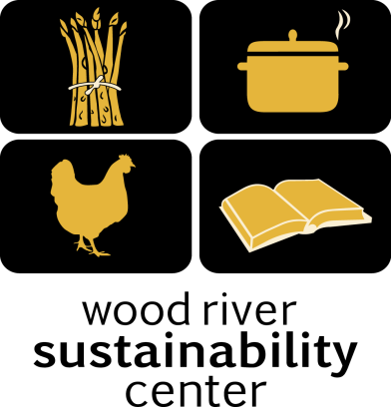

Local Food – Local People

Syringa Mountain School
Lunch Program
September

Tuesday, September 8th
Taco Salad
with Roasted Tomato Salsa and Queso Fresco, Rice and Beans
Includes onions, jalapeños, garlic, tomato and cilantro & Corn tortillas.
Gluten free!

Wednesday, September 9th
Chicken Caesar salad
with Hearty Sourdough Croutons
Includes egg, Tabasco olive oil, Dijon & lemon juice,
Dijon and anchovies in dressing. Parmesan cheese
Gluten Free except Croutons
Thursday, September 10th
Tomato and Basil Bisque
with Sourdough Bread and Green Salad
Includes garlic, olive oil and onion
Gluten Free except sourdough. Vegetarian.

Friday, September 11th
Chicken Teriyaki
with Brown Rice and Roasted Vegetables.
with Green Salad

Monday, September 14th
Vegetable Soup
with Green Beans, Corn, Peas, Onions, Garlic and Carrots
with Sourdough Bread and Green Salad

Tuesday, September 15th
Taco Salad
with Grass Fed Beef, Roasted Tomato Salsa and Queso Fresco, Rice and Beans
Includes onions, jalapeños, garlic, tomato and cilantro & Corn Tortilla Chips
Gluten free!

WRSC 308 S. River St. wrsustainabilitycenter@gmail.com 208-721-3114

Local Food – Local People
Syringa Mountain School
Lunch Program
September

Wednesday, September 16th
Spaghetti Bolognese Bake
with Sourdough Bread and Green Salad
Includes olive oil, red wine vinegar and herbs

Thursday, September 17th
Vegetable Stir Fry
Onions, Carrots, Celery, Broccoli, Green Onions and Garlic, Served with Brown Rice
Gluten free & Vegetarian.

Friday, September 18th
Chicken Pot Pie
With Chicken, Corn, Peas, Green Beans, Carrots, Celery and Potatoes.

Monday, September 21st
Vegetable Lasagna
with Sourdough Bread and Green Salad

Tuesday, September 22nd
Taco Salad
with Grass Fed Beef, Roasted Tomato Salsa and Queso Fresco, Rice and Beans
Includes onions, jalapeños, garlic, tomato and cilantro & Corn Tortilla Chips
Gluten free!

Wednesday, September 23rd
Chicken Teriyaki
with Brown Rice and Roasted Vegetables.
with Green Salad

Thursday, September 24th
Tomato and Basil Bisque
with Sourdough Bread and Green Salad
Includes garlic, olive oil and onion
Gluten Free except sourdough. Vegetarian.

Friday, September 25th
Chicken Caesar salad
with Hearty Sourdough Croutons, Includes egg, Tabasco olive oil, Dijon & lemon juice,
Dijon and anchovies in dressing. Parmesan cheese
Gluten Free except Croutons

WRSC 308 S. River St. wrsustainabilitycenter@gmail.com 208-721-3114

Local Food – Local People
Syringa Mountain School
Lunch Program
September

Monday, September 28th
Vegetable Stir Fry
Onions, Carrots, Celery, Broccoli, Green Onions and Garlic, Served with Brown Rice
Gluten free & Vegetarian.

Tuesday, September 29th
Chicken Caesar salad
with Hearty Sourdough Croutons
Includes egg, Tabasco olive oil, Dijon & lemon juice,
Dijon and anchovies in dressing. Parmesan cheese
Gluten Free except Croutons and Parm

Wednesday, September 30th
Spaghetti Bolognese Bake
with Sourdough Bread and Green Salad
Includes olive oil, red wine vinegar and herbs

WRSC 308 S. River St. wrsustainabilitycenter@gmail.com 208-721-3114

