INITIAL ENROLLMENT FORM

Cultivating eco-literate, compassionate, critical thinkers, prepared to solve the challenges of our world.
Please complete the following application if you wish to enroll your child at Syringa Mountain School, a free public charter school located in Hailey, Idaho opening August 2014. Thank you.
The enrollment window for Syringa Mountain School opens November 1, 2013 and closes February 3, 2014. Applications must be received in our office by February 3, 2014 at 5:00 PM. Applications received after the deadline will go to the bottom of the waiting list. State Law requires that an equitable selection process, such as a lottery, be held to determine who will be enrolled if more students apply than there are openings at any grade level.A lottery will be held, if needed, February 20, 2014 at 4:30 PM to determine placement on the waiting list for all grade levels.

Instructions: Completed applications may be mailed or submitted by e-mail.

Family Last Name_

Mother/Guardian Name: _ Father/Guardian Name

*Physical Address
*Mailing Address
Home Phone Cell Phone:

Father’s Work Phone
Mother’s Work Phone_

Email address for contact purposes:

Do you reside within our primary attendance area? (please check one) Yes
No
Don’t Know

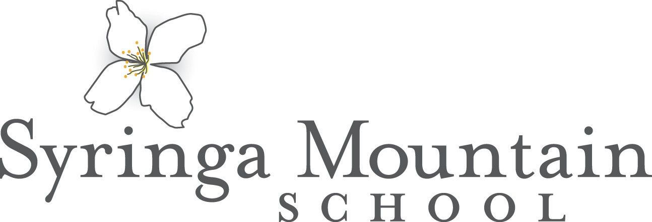
Please list all children you wish to enroll:

Name (first and last) | Grade for 2014-2015 | M/F | Birth Date | Last School Attended

Parent/Guardian Signature Date

*All prospective students will be given the opportunity to enroll regardless of gender, race, color, national or ethnic origin, religion, social or economic status or special needs.
*SMS reserves the right to revoke enrollment at any time under the following circumstances: 1) Poor attendance, 2)
Non-compliance with school rules, 3) Misrepresentation or falsification of any information on this form. Please send completed forms to: Syringa Mountain School, PO Box 3531, Hailey, Idaho 83333
Questions: (208) 720-6327 Email: marymgervase@yahoo.com

